Enterprise Java Beans 2.x
Advantages of EJB over Servlets

Stateless Session Beans over Servlets

EJB 2.1 Architecture
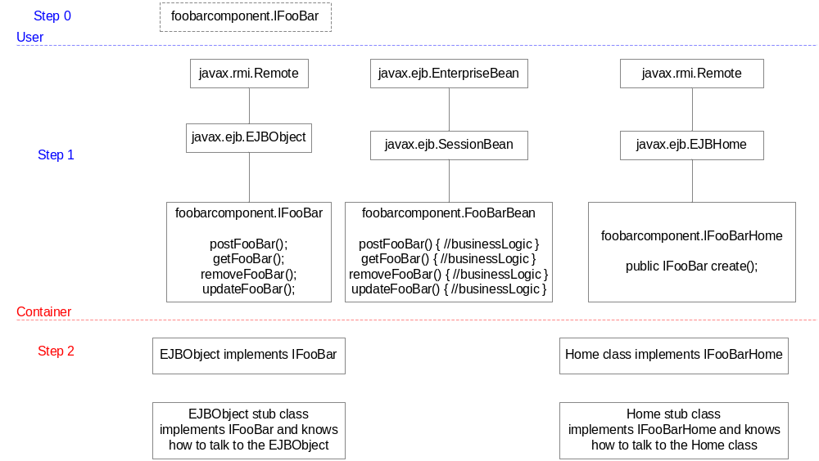

Enterprise Java Beans 3.0

Lifecycle Callback Methods

Define your own methods and assign the callback annotations

SSLB | SFSB | EB | MDB
postConstruct()  preDestroy() | postConstruct()  preDestroy()  prePassivate()  postActivate() |  | postConstruct()  preDestroy()

EJB 2.1 Fundamentals
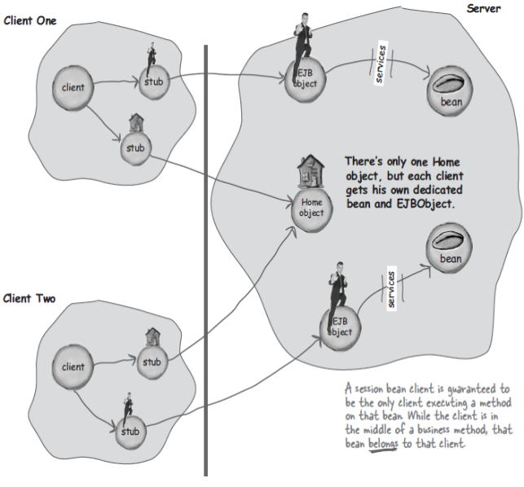 | A stateless session bean doesn’t need a EJBObject until it is actually involved in a method invocation. So the client gets a reference only to an EJBObject, but the bean isn’t associated with the EJBObject until the client calls a business method. At this point the bean slides out of the pool to service the method.  Stateful session beans are scalable too – if the stateful session bean client takes long time between method calls, the stateful session bean can be temporarily taken down and put in a state called passivation and can come back into active duty (activation) .  The state of a stateful bean is maintained until – if a client calls remove() nethod or the server crashes or if the bean timesout.
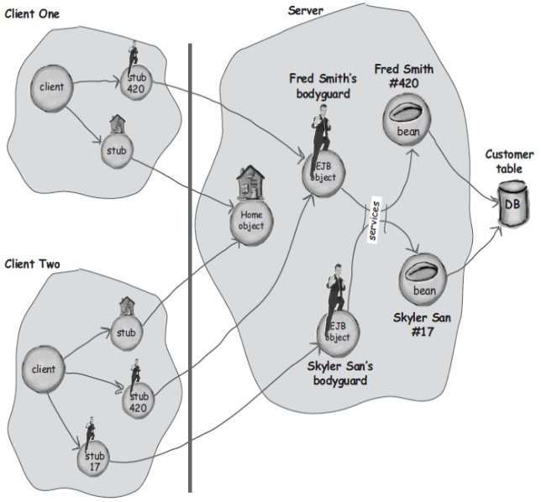
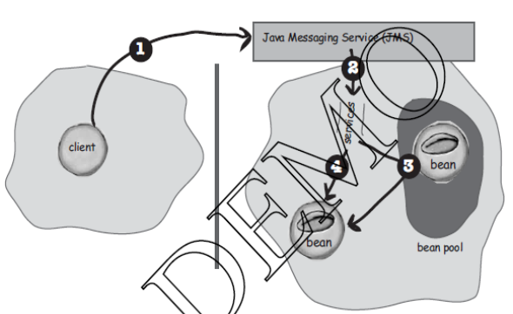 | Message-driven beans don’t have a client view. They don’t have interfaces ( remote or local) that expose methods to the client. In other words, message-driven beans don’t have a Home or EJBObject (component) interfaces.

EJB 2.1 Remote vs Local Client Views
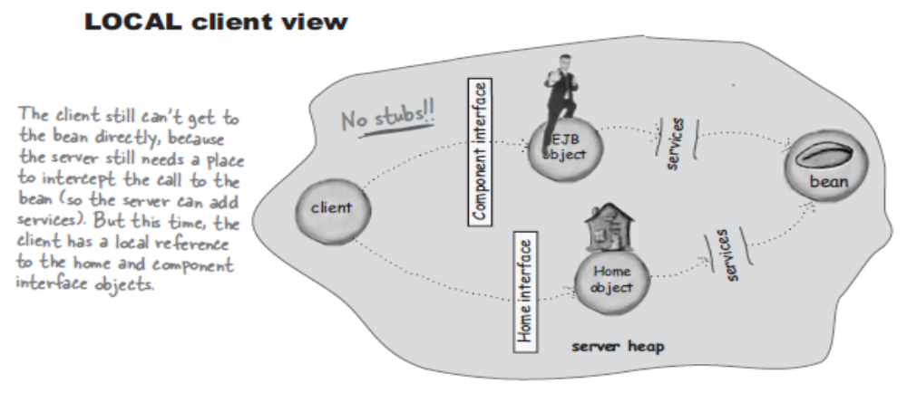
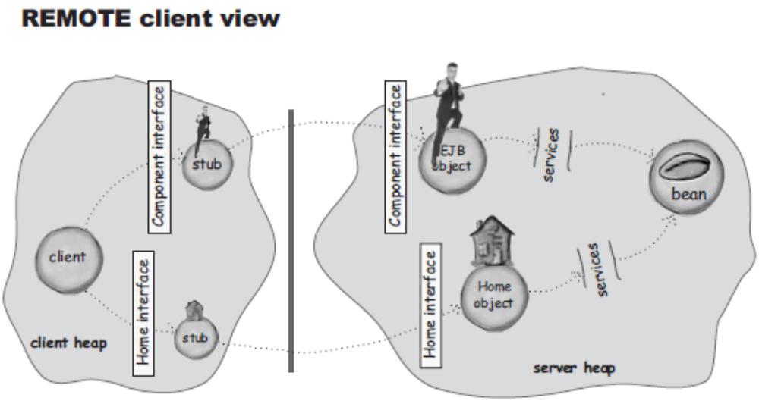
Home Interfaces in EJB 2.1
Home Interface is an implementation of Factory Pattern.

Client Code for EJB 2.1
public class AdviceClient {
public void getSessionBean(){
try {
Context initialContext = new InitialContext();
Object remoteHome = initialContext.lookup("Advisor");
AdviceHome adviceHome = (AdviceHome) PortableRemoteObject.narrow( remoteHome, AdviceHome.class );
Advisor advisor = adviceHome.create();
// invoke business method
advisor.getAdvice();
} catch ( RemoteException exRemote ) {
} catch ( CreateException exCreate ){
} catch ( Exception ex ){
}
}
}

Container Callback methods for Session Beans defined in SessionBean interface

Stateless Session Beans
setSessionContext(SessionContext sessionContext);
ejbActivate()
ejbPassivate()
ejbRemove()

SessionContext is the bean’s only lifeline to the container, and it lets the bean do things like get Security information about the calling client, force a transaction to rollback, get a reference to the bean’s own home or EJBObject and more.

Stateless session beans will exactly have 5 container calls backs. In addition to above they will have a no-argument ejbCreate() method for the corresponding Home interface’s create() method.
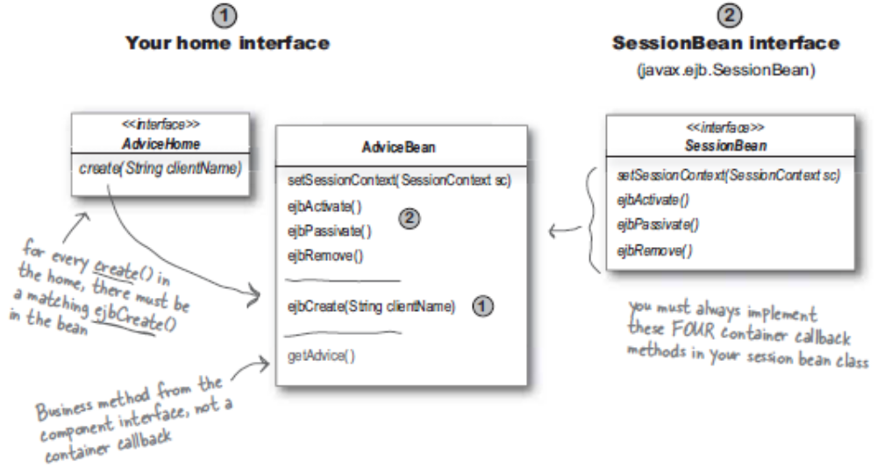

Stateful Session Beans
Stateful beans, will have atleast one create method. For eg. the stateful bean’s home can have

create()
create(String string)
createBigCustomer(String bigString)

and the corresponding will have three call back methods:

ejbCreate()
ejbCreate(String string)
ejbCreateBigCustomer(String string)

Container Callback methods for Message-Driven Beans defined in MessageDrivenBean interface
Message-driven beans are like stateless beans, they are pooled, and they have no individual state that affects their business logic.
javax.ejb.MessageDrivenBean interface has 2 container call back methods
ejbRemove();
setMessageDrivenContext();
javax.jms.MessageListerner interface define one method
onMessage();

A MDB will have at-most 3 container call back methods. Apart from the two defined by javax.ejb.MessageDrivenBean they define one method called ejbCreate() no-arg method.

Bean Managed Transactions vs Container Managed Transactions
Bean Managed Transactions | Container Managed Transactions
Used by Session Beans( SLSB & SFSB ) and MDBs | Used by all bean types
Must NOT be used by Entity beans | Compulsory for entity beans
Must not use setRollbackOnly() and getRollbackOnly() from EJBContext  Retrieves UserTransaction from EJBContext | Must not use setRollbackOnly()method of UserTransaction
No Nested Transactions in EJB

Exceptions in EJB
javax.rmi.RemoteException – Though it is checked exception, the container will wrap any runtime exception and throw it as a RemoteException to the client.
EJBException – is for Local Clients
Application Exceptions
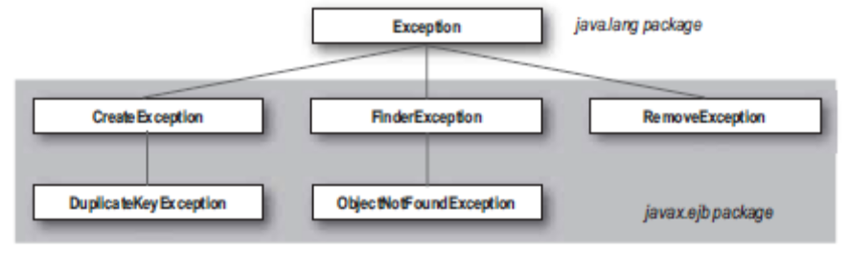
System Exceptions
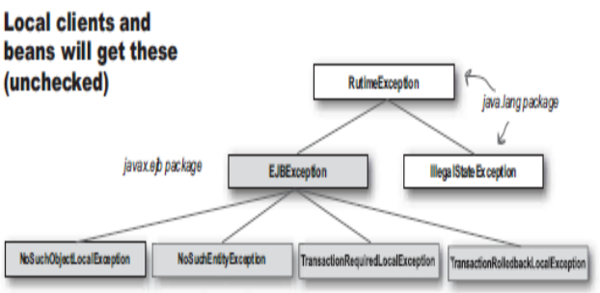 | 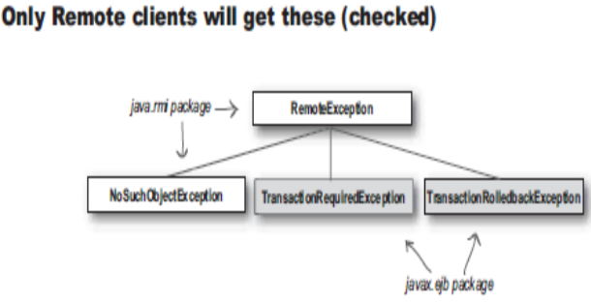

Annotations:
EJB components are container-managed objects. The container manipulates the behavior and internal state of the bean instances at runtime. For this behavior to occur, the EJB 2.1 specification defines a rigid component model the beans must conform to. Each EJB class must inherit from a certain abstract class that provides callback hooks into the container. Since Java supports only single inheritance, the rigid component model limits a developer's ability to build complex object structure using EJB components.

In EJB 3.0, all container services can be configured and delivered to any POJO in the application via annotations. In most cases, special component classes are not needed.

Interfaces:
Under the EJB 3.0 API, the business interface of an enterprise bean is a plain Java interface, not an EJBObject or EJBLocalObject interface.
Remember in EJB 2.1

javax.rmi.Remote javax.ejb.EnterpriseBean javax.rmi.Remote
/\ /\ /\
|| || ||
|| || ||
|| || ||
javax.ejb.EJBObject javax.ejb.SessionBean javax.ejb.EJBHome
/\ /\ /\
|| || ||
|| || ||
|| || ||
foo.FooBusinessRemoteInterface foo.FooBusinessInterfaceImplBean foo.FooBusinessRemoteHome
void createFoo(); void createFoo(); FooBusinessRemoteInterface create();
void readFoo(); void readFoo();
void updateFoo(); void updateFoo();
void deleteFoo(); void deleteFoo();
-------------------------------------------------------------------------------------------------
javax.ejb.EnterpriseBean
/\
||
||
||
javax.ejb.EJBLocalObject javax.ejb.SessionBean javax.ejb.EJBLocalHome
/\ /\ /\
|| || ||
|| || ||
|| || ||
foo.FooBusinessLocalInterface foo.FooBusinessInterfaceImplBean foo.FooBusinessLocalHome
void createFoo(); void createFoo(); FooBusinessRemoteInterface create();
void readFoo(); void readFoo();
void updateFoo(); void updateFoo();
void deleteFoo(); void deleteFoo();

Exceptions:
The methods of the business interface may declare arbitrary application exceptions. However, the methods of the business interface should not throw the java.rmi.RemoteException, even if the interface is a remote business interface, the bean class is annotated WebService, or the method is annotated as WebMethod. If problems are encountered at the protocol level, an EJBException which wraps the underlying RemoteException is thrown by the container.

Home Interfaces:
The requirement for Home interfaces has been eliminated. Session beans are no longer required to have home interfaces.
EJB 3.0 entities do not have home interfaces. A client may create an instance of an entity type by means of the new operation. The entity instance may be persisted by means of the EntityManager APIs defined in the Java Persistence API document.

Container CallBack Methods:
In EJB 3.0, you can specify any bean method as a callback by annotating it with the following annotations. Unlike EJB 2.1, where all callback methods must be implemented even if they are empty, EJB 3.0 beans can have any number of callback methods with any method name.
@PostConstruct: The container immediately calls the annotated method after a bean instance is instantiated. This annotation applies to both stateless and stateful session beans.
@PreDestroy: The annotated method is called before the container destroys an unused or expired bean instance from its object pool. This annotation is applicable to both stateless and stateful session beans.
@PrePassivate: If a stateful session bean instance is idle for too long, the container might passivate it and store its state to a cache. The method tagged by this annotation is called before the container passivates the bean instance. This annotation applies to stateful session beans.
@PostActivate: When the client uses the passivated stateful session bean again, a new instance is created and the bean state is restored. The method tagged by this annotation is called when the activated bean instance is ready. This annotation is only applicable to stateful session beans.
@Init: This annotation designates initialization methods for a stateful session bean. It differs from the @PostConstruct annotation in that multiple methods can be tagged with @Init in a stateful session bean. However, each bean instance can have only one @Init method invoked. The EJB 3.0 container determines which @Init method to invoke depending on how the bean is created (see the EJB 3.0 specification for details). The @PostConstruct method is called after the @Init method.
@Remove: Another useful annotation for a lifecycle method, especially for stateful session beans, is @Remove. When the application calls the @Remove tagged method through the stub, the container knows to remove the bean instance from the object pool after the method executes.

Dependency Injections:
To access service objects, you need to look up stub objects (for session beans) or message queues (for MDBs) from the server's JNDI. JNDI lookup is a key step that decouples the client from the actual implementation of the service object. However, plain JNDI lookup based on string names is not elegant. Here are a few reasons:
- The client and service must agree on the string-based name. It is a contract not enforced by the compiler or any deployment-time checks.
- The type of the retrieved service object is not checked at compile-time and could result in a casting error at runtime.
- The verbose lookup code with its own try-catch block is repeated and littered across the application.
EJB 3.0 features a simple and elegant way to make decoupled service objects and resources available to any POJO.

public class CalculatorMDB implements MessageListener {
@EJB Calculator cal;
// Use the cal variable
// ... ...
}

public class CalculatorMDB implements MessageListener {
Calculator cal;
@EJB
public void setCal (Calculator cal) {
this.cal = cal;
}
// Use the cal variable
// ... ...
}

@Resource
TimerService tms;
@Resource
SessionContext ctx;
@Resource (name="DefaultDS")
DataSource myDb;
@Resource (name="ConnectionFactory")
QueueConnectionFactory factory;
@Resource (name="queue/A")
Queue queue;

Security:
@Stateless
@SecurityDomain("other")
public class CalculatorBean implements Calculator {
@RolesAllowed({"AdminUser"})
public void addFund (String name, double growthrate) {
// ... ...
}
@RolesAllowed({"AdminUser"})
public void addInvestor (String name, int start, int end) {
// ... ...
}

@PermitAll
public Collection <Fund> getFunds () {
// ... ...
}

// ... ...
@RolesAllowed({"RegularUser"})
public double calculate (int fundId, int investorId,
double saving) {
// ... ...
}
}

Transaction Services
When the EntityManager object is used in a session bean, it is tied with the server's transaction context. The EntityManager commits and synchronizes its contents to the database when the server's transaction commits. In a session bean, the server transaction commits at the end of the call stack by default. Of course, you can also specify the detailed transactional properties of each business method via annotations. The example below shows how to declare a new transaction for a session bean method:

@TransactionAttribute(TransactionAttributeType.REQUIRESNEW)
public void update () {
// Update Person objects in this method
// and all updates are committed and flushed
// to the database at the end of this method.
}

Generic Interceptors:
Both transaction and security services can be considered runtime interceptors managed by the container. The container intercepts the method calls from the EJB stub and applies transaction context or security constraints around the calls.

In EJB 3.0, you can extend the container services by writing your own interceptors. Using the @AroundInvoke annotation, you can specify any bean method as the interceptor method that will execute before and after any other bean method runs. In the following example, the log() method is the interceptor that profiles and logs the execution time of other bean methods:

@Stateless
@Interceptors({
com.acme.AccountAudit.class,
com.acme.Metrics.class,
com.acme.CustomSecurity.class
})
public class AccountManagementBean implements AccountManagement {

public void createAccount(int accountNumber, AccountDetails details) { ... }
public void deleteAccount(int accountNumber) { ... }
public void activateAccount(int accountNumber) { ... }
public void deactivateAccount(int accountNumber) { ... }
...
}

public class Metrics {
@AroundInvoke
public Object profile(InvocationContext inv) throws Exception {
long time = System.currentTimeMillis();
try {
return inv.proceed();
} finally {
long endTime = time - System.currentTimeMillis();
System.out.println(inv.getMethod() + " took " + endTime + "
milliseconds.");
}
}
}

public class AccountAudit {
@AroundInvoke
public Object auditAccountOperation(InvocationContext inv) throws
Exception {
try {
Object result = inv.proceed();
Auditor.audit(inv.getMethod().getName(), inv.getParameters()[0]);
return result;
} catch (Exception ex) {
Auditor.auditFailure(ex);
throw ex;
}
}
}
public class CustomSecurity {
@Resource EJBContext ctx;
@AroundInvoke
public Object customSecurity(InvocationContext inv) throws Exception{
doCustomSecurityCheck(ctx.getCallerPrincipal());
return inv.proceed();
}
private void doCustomSecurityCheck(Principal caller) throws SecurityException {...
}
}

